Mitten Measurement Worksheet 2

If you are working in a measurement other than inches make sure to stay consistent throughout.

Gauge:_________ stitches and __________ rows per inch

Hand:

Total Width: A _________ inches x ___________ stitches per inch = ___________ stitches(G)

Total Hand Length: B _________ inches x ____________rows per inch = ______________ rows(H)

Length to Pinky: C __________ inches x _____________ rows per inch = _____________ rows(I)

Cuff Length: ___________ inches x ____________ rows per inch = ____________ rows(J)

Total Mitten Length in Rows: H___________ + J ____________ = _____________ rows(K)

Thumb:

Length to Divide: D ___________ inches x ______________ rows per inch = __________ rows (L)

Length from Divide to Thumb Top: E ___________ inches x _____________rows per inch = ___________ rows(M)

Thumb Width: F ___________ inches x _____________ stitches per inch = ___________ stitches(N)

Copyright 2016 Kathy Lewinski JustCraftyEnough.com

Sample mitten template showing how the numbers you get on page 1 fit into your mitten pattern.
(This is based on my measurements. Your template will use your numbers for stitch and row counts.)
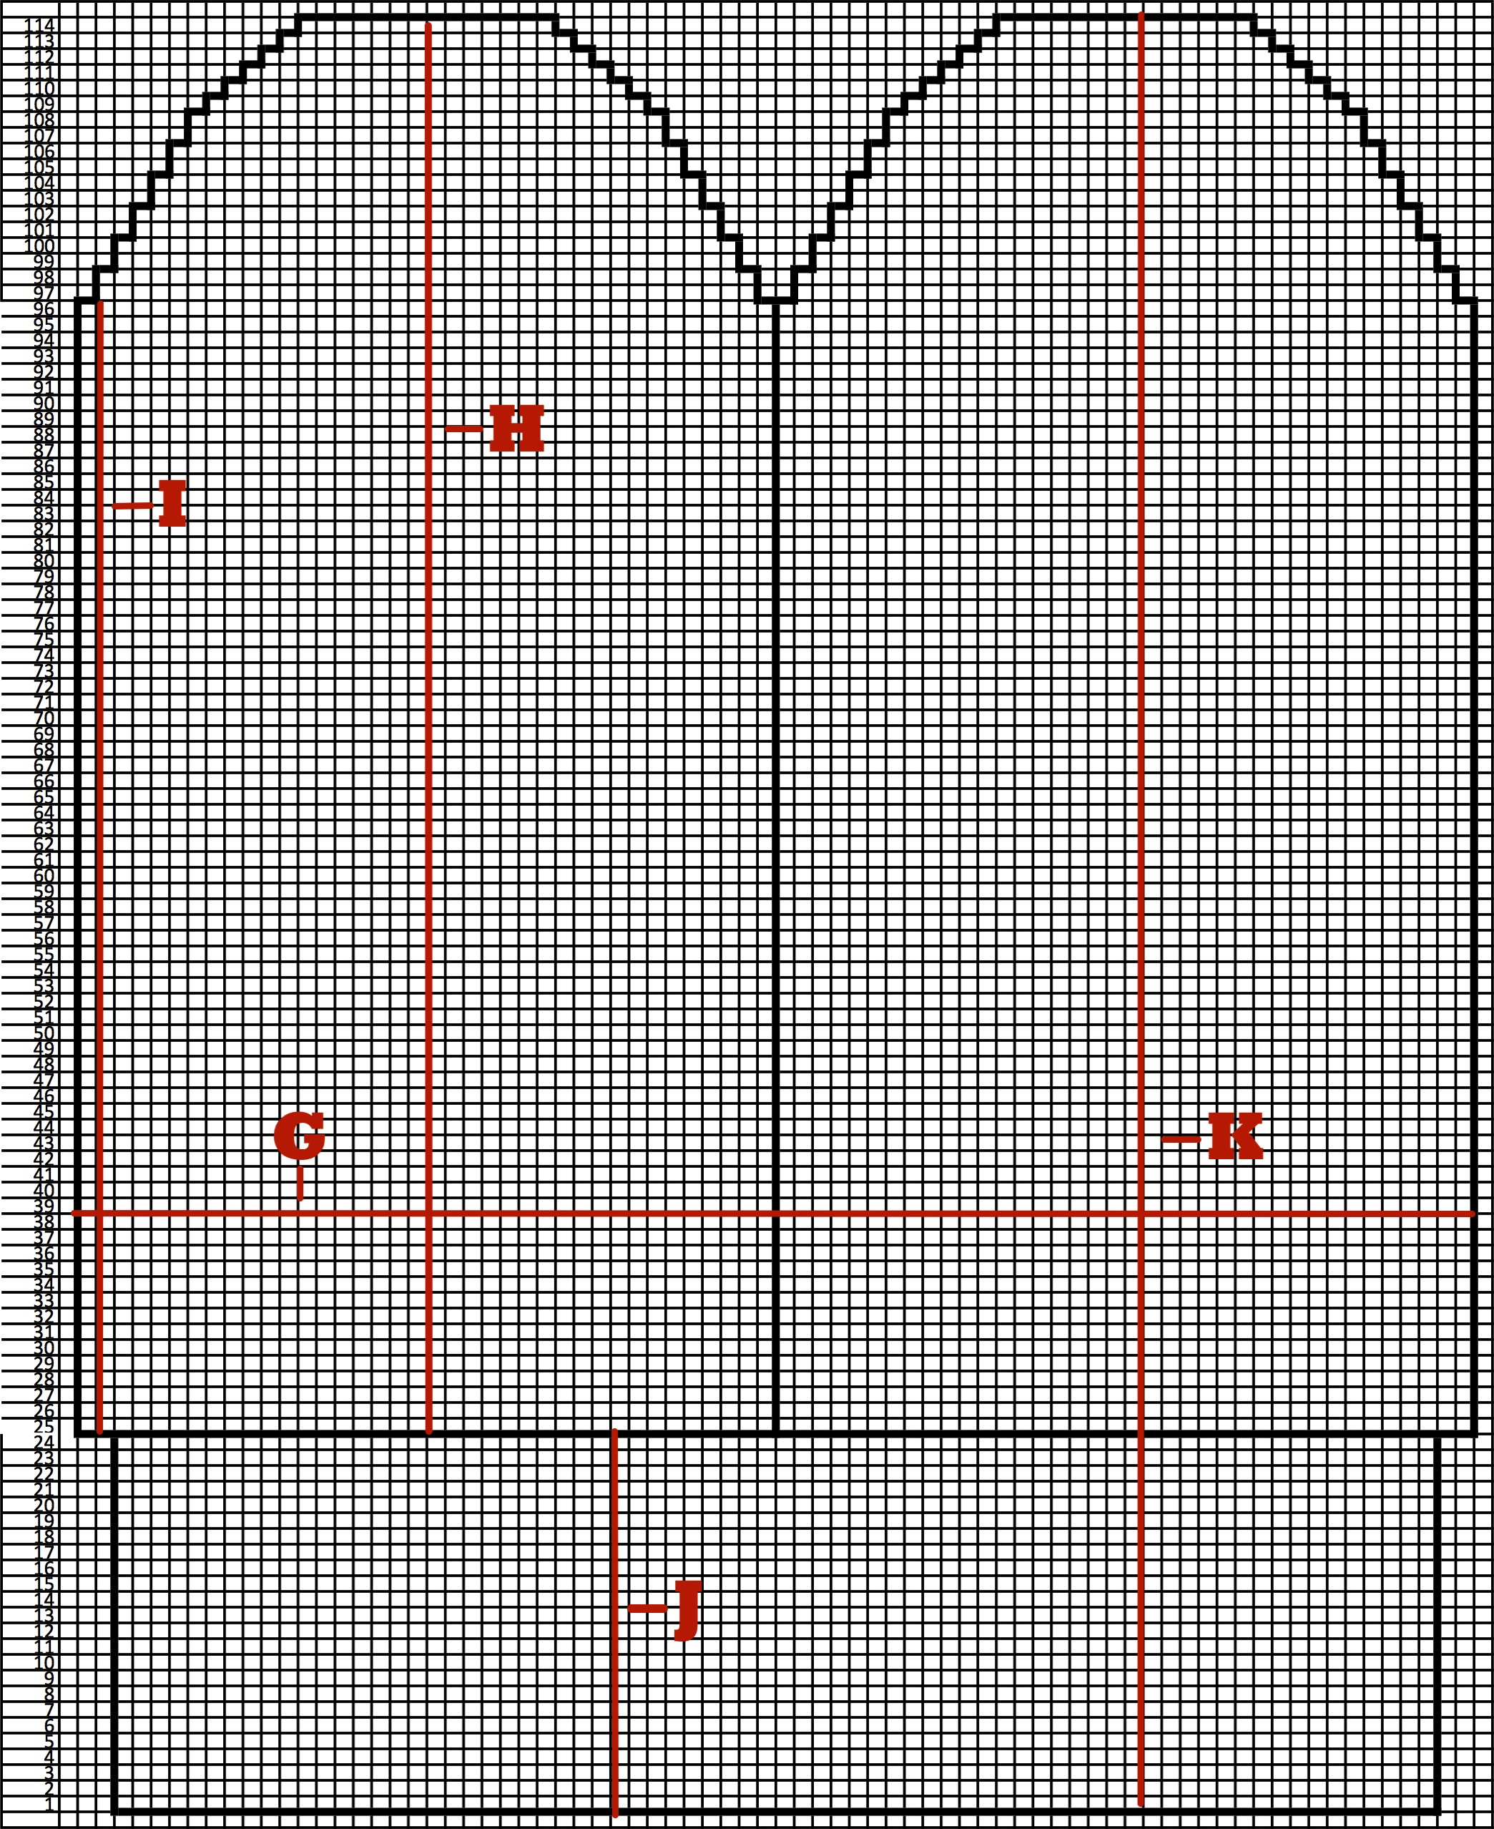

Copyright 2016 Kathy Lewinski JustCraftyEnough.com

