Mitten Measurement Worksheet 1

Name:
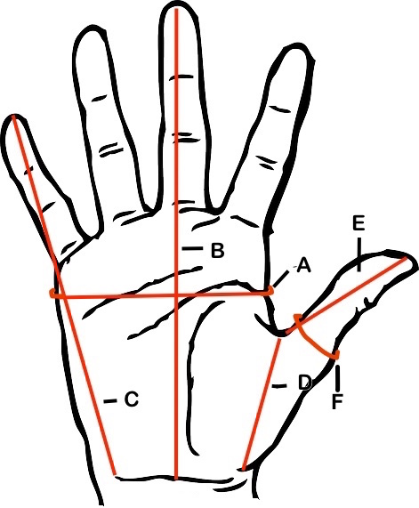

Measure the circumference of your hand for A and the circumference of your thumb for F.

A :

B:

C:

D:

E:

F:

Copyright 2016 Kathy Lewinski JustCraftyEnough.com

